Randoop.NET manual
Randoop.NET version Beta 1
Authors: Carlos Pacheco, Shuvendu Lahiri, Tom Ball

1. Introduction 1
2. Quick start 2
3. Randoop’s output 3
4. Auxiliary tools 4
5. Options 5
6. Configuration files 5
7. Developer notes 7
8. Current limitations 7
9. Questions and Feedback 7

Introduction

Randoop.NET is an automated, randomized test generation tool for .Net assemblies. It takes as input one or more assemblies (.dll or .exe files), plus optional command-line arguments, and outputs a set of test cases for the assemblies. Each generated test case is a C# class that exercises the code in the assembly via its defined API. In addition, Randoop.NET classifies each test according to its runtime behavior—a test case can behave normally, or it can reveal a potential error in the assembly by exhibiting a sequence of API calls that leads to undesirable behavior such as null pointer dereferences, access violations, etc.

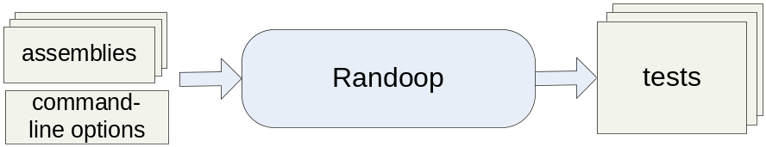

By default, Randoop.NET outputs only test cases that reveal exceptional or problematic behavior (i.e. access violations or assertion violations), and can be used as a bug-finding tool. Randoop.NET is fully automatic, and that for the potential error it finds the tool creates test cases that reproduce the error-revealing behavior.

NOTE: Randoop.NET tests code by executing random invocations of API calls. This can lead to potentially undesirable behaviors—if the code under test can delete files, open connections, send items to a printer, etc. then there is a chance that Randoop.NET will invoke the code that performs these actions with arbitrary input parameters. We strongly recommend running Randoop.NET under a controlled environment (e.g. machines reserved for testing), not under normal development machines. The examples in this manual, however, are safe to run on any machine.

Randoop.NET has been used to find bugs in a number of .NET framework libraries, including null-dereference and index-out-of-bound exceptions that violate the design guidelines for .NET library developers, an infinite loop in System.Xml, access violations in System.Drawing and mscorlib.dll, etc. The CLR (Common Language Runtime) team has used Randoop.NET to find bugs in their libraries.

Quick start

This section walks you through an example use of Randoop.

Calling Randoop. Invoke Randoop.NET as follows:

Option 1: Using the Binary download (from the randoop.zip)

> randoop\bin\randoop.exe /timelimit:10
C:\WINDOWS\Microsoft.NET\Framework\v2.0.50727\System.Xml.dll

Option 2: Using the source download (after building the sources)

> randoop\bin\Debug\randoop.exe /timelimit:10
C:\WINDOWS\Microsoft.NET\Framework\v2.0.50727\System.Xml.dll

NOTE. If an assembly has methods that send output to stdout or stderr, output may appear onscreen as Randoop.NET generates test cases. For the most part, you can safely, dismiss the output—it’s a side-effect of Randoop.NET executing the code under test.

Randoop’s output. After generating tests for 10 seconds, Randoop.NET opens IE to an html file that summarizes the results (if IE is not open automatically, you can open it by hand—Randoop.NET prints out a message at the end with the location of the html file). The directory randoop_output contains the generated tests, under a folder whose name is of the form run_month_day_year_hr_min_sec (for example, run_oct_10_2006_11h_11m_24s).

Running the generated tests. Each generated test has a main entrypoint; you can compile each test individually (for example, via csc or in Visual Studio) and run it to reproduce the behavior.

NOTE. If the assembly under test does not reside in the Global Assembly Cache (GAC), you will need to (1) reference it when you compile the generated test cases (e.g. with the /r option in csc), and (2) ensure that all required assemblies are in the same directory as the executable.

NOTE: Sometimes a test will not repro. Since Randoop.NET does not execute each test in a separate, clean process (for performance reasons), a test that may sometimes behave differently when run outside of Randoop.

Randoop.NET’s output

Randoop.NET outputs a set of tests. Each test is a compilable C# source files; below is an example. The test declares a single main entry point that contains the code under test (between the comments //BEGIN TEST and //END TEST). The code under test is wrapped in a try-catch clause. When executed, the test prints out a message with the result of the execution.

Exit codes. Randoop’s tests exit with exit code 99 or 100. An exit code 100 means that the test behaved as expected, i.e. as observed by Randoop.NET when the test was originally created. For example, the test below was observed by Randoop.NET to throw a FormatException. If during execution the test throws such an exception, it gets caught in a catch-clause and the test exits with code 100. Any other behavior—normal termination, or an exception other than a FormatException—causes the test to exit with code 99.

Comments. You’ll notice that emitted tests are decorated with comments. The comments are using by auxiliary tools to parse information about each test during post-processing steps like minimization. See next section.

//LAST ACTION: System.Xml.XmlConvert.Char ToChar(System.String)
//EXCEPTION: System.FormatException
using System.Xml;
using System;
public class RandoopTest1262
{
public static int Main()
{
try
{
//BEGIN TEST
System.DateTime v2 =
(System.DateTime)(System.Array.CreateInstance(typeof(System.DateTime), 1))
.GetValue(0);
System.Xml.XmlDateTimeSerializationMode v3 =
System.Xml.XmlDateTimeSerializationMode.Local;
System.String v4 = System.Xml.XmlConvert.ToString(v2, v3) ;
System.Char v5 = System.Xml.XmlConvert.ToChar((System.String)v4) ;
//END TEST
System.Console.WriteLine("This was unexpected behavior
(expected an exception). Will exit with code 99.");
return 99;
}
catch (System.FormatException e)
{
System.Console.WriteLine("//EXCEPTION:" + e.GetType().FullName);
System.Console.WriteLine("This was expected behavior.
Will exit with code 100.");
return 100;
}
catch (System.Exception e)
{
System.Console.WriteLine("//EXCEPTION:" + e.GetType().FullName);
System.Console.WriteLine("//STACK TRACE:");
System.Console.WriteLine(e.StackTrace);
System.Console.WriteLine();
System.Console.WriteLine("This was unexpected behavior.
Will exit with code 99.");
return 99;
}
}
}
//REFASSEMBLY: C:\windows\assembly\GAC_MSIL\System.Xml\2.0.0.0__b77a5c561934e089\System.Xml.dll
//REFASSEMBLY: C:\WINDOWS\Microsoft.NET\Framework\v2.0.50727\mscorlib.dll

Auxiliary tools

Pageheap. Randoop.NET has an option in which it runs tests using pageheap, which allows it to detect access violations that it might not detect otherwise. See /pageheap option.

NOTE: if Randoop.NET reports test cases that cause access violations, you will have to run any AV-inducing tests with pageheap enabled to reproduce the violation.

Minimization. Randoop.NET can minimize tests, meaning it can attempt to transform each test into a smaller one that still exhibits the same exception. The minimizer works by removing one line at a time from each test to be minimized, and checking that (1) the test still compiles, and (2) the same type of exception occurs on the smaller test. You can invoke the minimizer as a separate utility, which works on any Randoop-generated test case. Invoke it as follows:

> Randoop minimize [filename]+

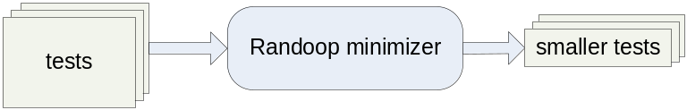

Where filename is the name of a Randoop-generated test case, or the name of a directory containing such tests. In the latter case, Randoop.NET attempts to minimize any tests contained in the directory.

Redundant test removal. Randoop.NET can reduce tests, meaning it removes tests that it considers redundant. We currently use a very simple strategy of redundancy: two tests are redundant if they end with the same method call and throw the same exception. The reducer keeps only one non-redundant test for each method/exception pair. (“Smarter” strategy: sequence-based reduction – A test case t is redundant for a test suite S if and only if there exists a test case t’ from S, which is seq(t) is a subset of seq(t’).) Invoke the reducer as follows:

> Randoop reduce [filename]+ \
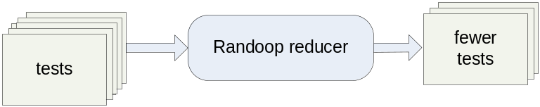

Collecting generation statistics. As it generates tests, Randoop.NET collects statistics about its generation process, including how many times it attempted to use specific methods, how many times a method was called, etc. It outputs the statistics to files ending in “stats.txt”. You can summarize the statistics by invoking the following (this is done automatically after a run of Randoop, but you can do it separately).

> Randoop statistics [filename]+ \

See /stats:F and /keepstatlogs options.
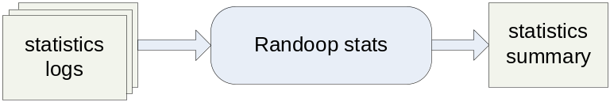

Options

Randoop.NET has several options to control its behavior. An up-to-date list of the options is available by invoking Randoop.NET with no arguments or with /?. The options are classified into the following categories.

- Controlling members that are allowed/forbidden.
- Specifying configuration files other than the default.
- Controlling test generation.
- Controlling which and where tests are output.
- Using auxiliary tools during test generation.
- Using auxiliary tools after test generation.

Configuration files

Randoop.NET uses a set of configuration files to determine which types, methods, etc. to generate tests for, and which primitive values to use as inputs to methods. There are 20 configuration files.

API Filters. For the next 6 files, each line in the file is interpreted as a wildcard pattern. The pattern should not contain whitespace (if it does, it will be removed before applying the pattern). A wildcard pattern can contain '*' characters. A '*' matches any sequence of strings, including the empty string. Examples of wildcard patterns:

System.Xml* matches any string that starts with "System.Xml"
*Reflection* matches any string that contains "Reflection"

For more examples see <randoop>\default_config_files.

- require_types.txt. Use only types that match at least one wildcard pattern in the given file. The pattern is matched against the result of calling T.ToString() on each type.

- require_members.txt. Use only methods and constructors that match at least one wildcard pattern in the given file. The pattern is matched against the result of calling M.ToString()/returntype on each member.

- require_fields.txt. Use only fields that match at least one wildcard pattern in the given file. The pattern is matched against the result of calling F.ToString() on each field.

- forbid_types.txt. Avoid types that match at least one wildcard pattern in the given file. The pattern is matched against the result of calling T.ToString() on each type.

- forbid_members.txt. Avoid methods and constructors that match at least one wildcard pattern in the given file. The pattern is matched against the result of calling M.ToString() on each member.

- forbid_fields.txt. Avoid fields that match at least one wildcard pattern in the given file. The pattern is matched against the result of calling F.ToString() on each field.
Determining the set of entities under test. Below is a more precise description
of the steps used to determine the entities used to create tests.

Steps i-iv determine the types used to create tests.

- Collect all the public types in the assemblies given as arguments to Randoop. Call the resulting set of types TS.
- If /internal is given, add all internal types to TS.
- Remove from TS any type that does not match a wildcard specified in the require_types.txt file.
- Remove from TS any type that matches a wildcard specified in the forbid_types.txt file.

Step v determines the methods, constructors and fields used to create tests.

- For each type in TS:
  - Collect all the public methods, constructors and fields declared by the types in TS. Call the resulting set MS.
  - If /nostatic is given, remove all static members from MS.
  - Remove any method or constructor that does not match a wildcard specified in the require_members.txt file. Similarly for require_fields.txt
  - Remove any method or constructor that matches a wildcard specified in the forbid_membres.txt file. Similarly for forbid_fields.txt.

Simple type seeds. The remaining 14 files specify simple type values (or strings) to use when calling an API that requires a simple type as input. The values for a given type are specified in a file, and each line in the file should contain a string representation of the value that can be parsed into the given type. For example, the file seed_int.txt must contain one int per line, such as "3" or "-1". More specifically, for simple type T, each line should contain a string that can be passed to T.Parse(string). The exception is the file seed_string.txt, where each line can contain any string.

- seed_sbyte.txt
- seed_byte.txt
- seed_short.txt
- seed_ushort.txt
- seed_int.txt
- seed_uint.txt
- seed_long.txt
- seed_ulong.txt
- seed_char.txt
- seed_float.txt
- seed_double.txt
- seed_bool.txt
- seed_decimal.txt
- seed_string.txt

Developer notes

If you’re interested in understanding of modifying Randoop.NET code, please see the document “Randoop.NET developer notes.”

Current limitations

- Randoop.NET makes no attempt to handle concurrency in any way.
- Randoop.NET does not currently explore methods that take or return pointers, or methods that include “&” or “out” parameters. There is also limited support for generics: a method that returns a value of a generic type can be used, but Randoop.NET does not itself construct values of generic types to pass to methods that require them (such methods are only called with null). There is no fundamental reason for this; we just haven’t gotten around to adding support for this in Randoop.

Questions and Feedback

Please use the Codeplex IssueTracker feature on the Codeplex project site to send us bug reports and suggestions.

